PukSetu Websites for references:

For overall layout of web page

<https://www.nic.in/>

For registration of farmer

<https://pmkisan.gov.in/RegistrationForm.aspx>

for videos or crop search of traders

<https://bhulekh.mahabhumi.gov.in/>

<https://pmfby.gov.in/>

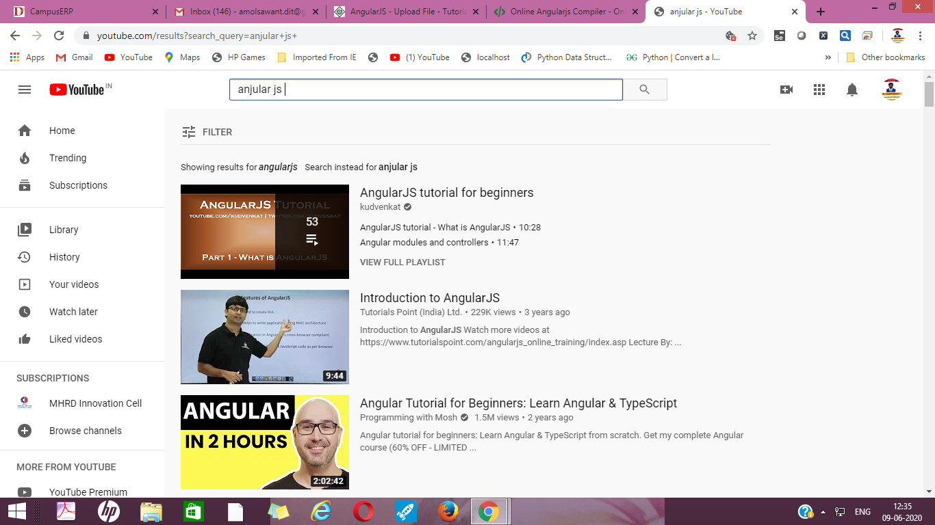

**Task Assign Details**

1. Front page home page - - Akshay
2. Farmer registration/signup - - Arshi
3. Pik registration- Yash
4. Traders registration- Mikita
5. pik Search --- Kirti separate page
6. video display and filter- Kunal
7. Sign and dashboard for setu center owner point of view- Siddhant
8. Report page (setu center)
   1. Farmer report
   2. Trader report
   3. Pik report
9. Help

**Technologies**

HTML5 -- front end design

CSS3 --front end design

Angular JS front end client side dynamic scripting

Django/Flask-Python -- Backend server side scripting

MySQL/Mongodb --Backend Database

Selenium Webdrive -- Automation Testing